1.3.17

**Job description**

Short description: Change the existing app to transfer contacts from MS SQL to MS Outlook

You will get a ms sql express database with 2 tables: Contacts + Addresses, like this:

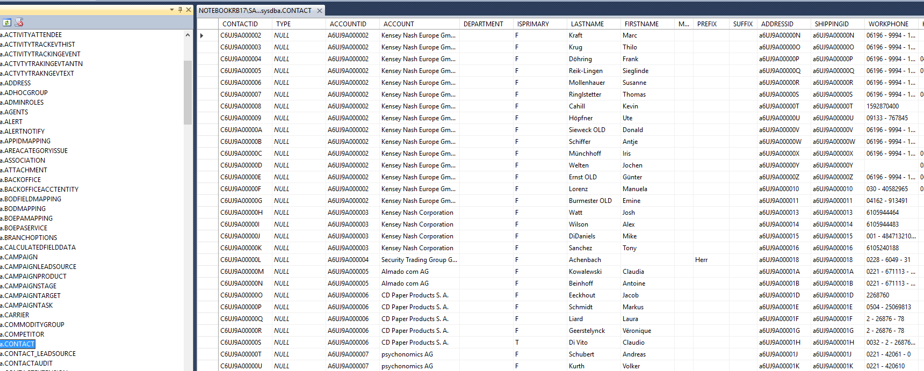

1. When everything is done I need the source code as well. This is just for my security reasons. If we work together well and I need modifications you can do them of course and I will pay for once the app is completed.
2. You have to do good tests. Of course I will test, too, but I am not the one to find bugs. You have to make sure the software works close to 100% well befor you give it to me!
3. There is a flag field (OUTLOOKRB). If this is set to T (=true), then this contact goes to OL (I have about 6000 contacts in SQL but I want only 100 or 200 or so in Outlook)  
   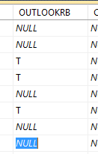
4. There are two transfer modes (like it is already): Sync all or sync updates only. If “Updates only” you transfer all new contacts plus the contacts changed since last time. In the ini file you can see when the last transfer was. This is to make the cycle fast. The contact table and the address table have fields like “last changed”. Attention: If the address has changed in SQL (for example zip code or city) the last changed date (modify date) will be set only in the address table, not in the contact table so you have to check the modify date in both tables.  
   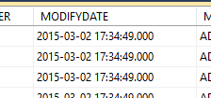
5. You need to transfer the CONTACTID from SQL to Outlook as well to the field ORGANIZATIONAL ID NUMBER (I think this one is the best). Via this field it is visible if the contact comes from the SQL database or if it is an original Outlook contact.

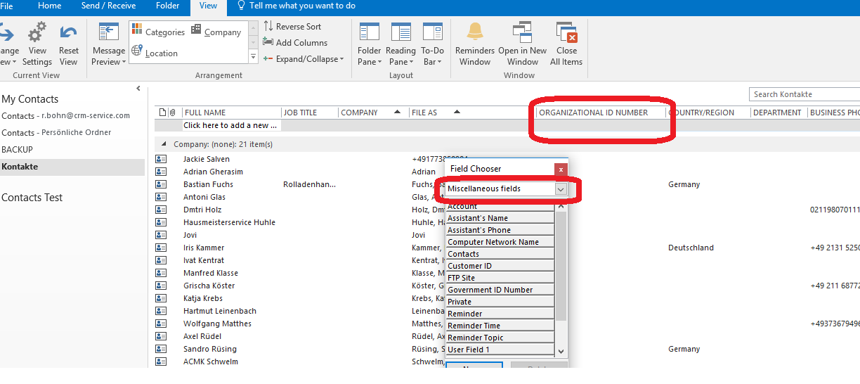

1. If “transfer all” you transfer all contacts that are flagged (transfer to OL=true) and you check if there is any contact in OL that has an *Organizational ID Number* that is not in SQL (anymore) and then you delete it in OL.
2. You never touch contacts in OL that have no *Organizitional ID Number* because they are not part of thee sync game.
3. We start from the existing app:

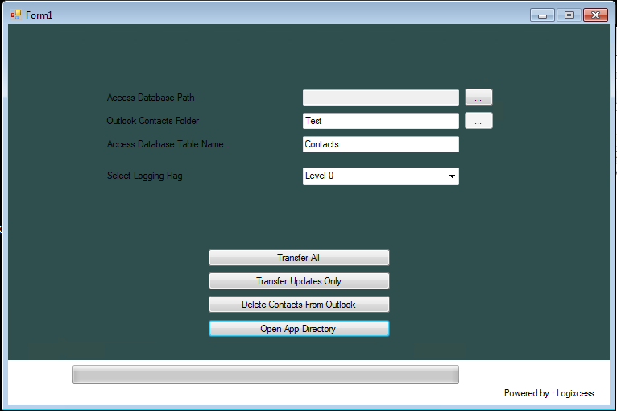

1. Replace „Form1“ in the headline with „Infor CRM to Outlook“
2. “Powered by …” please hide. You can write “About” and if you click on it you can show it but I also need “CRM-Service” written there somehow”
3. Change the green to white or light blue. See my website [www.crm-service.com](http://www.crm-service.com) for designs.
4. Line 1: Access Database Path … is not needed anymore
5. Line 3: Access Database Table name is not needed anymore
6. Rest can stay
7. Make also a field: Number of contacts in SQL database (including a refresh button to recount)
8. Make also a field: Last transfer …
9. Make also a field: Transfer updates only every minutes …. Field to enter how many minutes, for example 5 or 60 …
10. When minimizing the app but it to the systray, not to the taskbar:  
    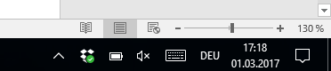
11. Filename of the app: InforCRMtoOL.exe (with proper icon)
12. ini file to it: InforCRMtoOL.ini
13. Don’t put it in a folder like this:

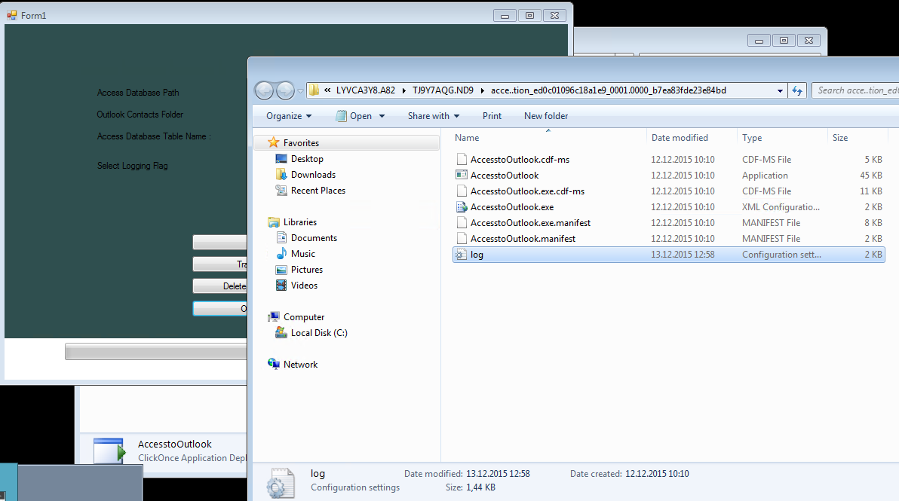

1. It has to go to C:\InfortoOL or something like this
2. Best would be no setup necessary, just copy exe and ini (and dlls) to a folder and start it …
3. Log file goes to same folder as program itself
4. Logging is fine for the moment as it is, you can keep it like this.
5. It should look like this:

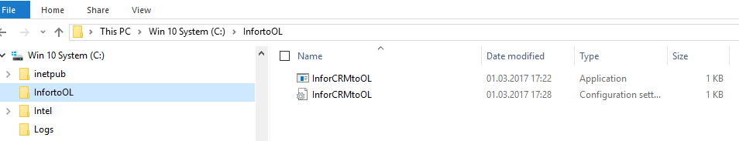

1. For your information:

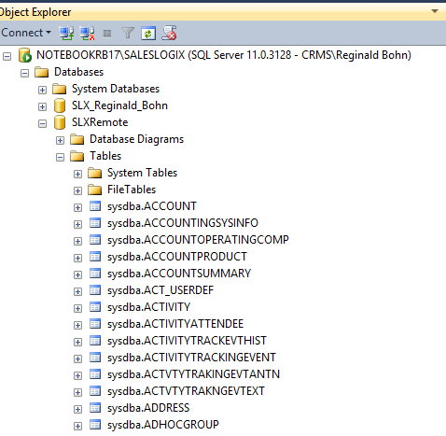

1. **Ini file:**

[Settings]

;Connection string to connect to MS SQL Express database (version 2008, 2012, 2014, 2016)

Server=NOTEBOOKRB17\SALESLOGIX;Database=SLXRemote;User id=sa;Password=123

Log file="C:\InfortoOL"

Logging level=0

;can be 0, 1, 2, 3

Last Run=28.02.2017 20:12:51

Repeat Minutes=30

;This means every 30 minute an upadate only transfer is done. If set to 0 no autotransfer

Outlook Contact Folder=Contacts Test

;Outlook Version 2013, 2016 32bit

1. Be aware that in the real database on my computer the tables are sysdba.address and sysdba.contact. Your test database it is dbo.address and dbo.contacts
2. Test Contact Michael Reimann with Home Address (all these fields have to be taken over to Outlook):

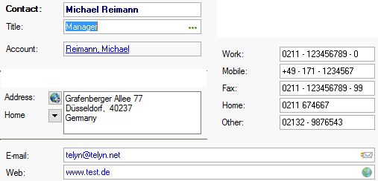

1. Test Contact Michael Reimann with Office Address (all these fields have to be taken over to Outlook):

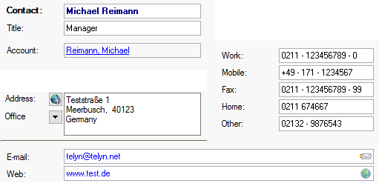

1. Field mapping regarding phone fields:

Infor CRM (SQL) Outlook

Work Business  
Mobile Mobile  
Fax Business Fax  
Home Home  
Other Other

1. Address fiels to be taken to Outlook. If a contact has a Home address and an Office address, both fields have to be taken over:

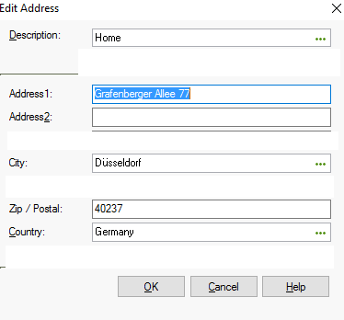

1. The addresse are mainly Home and Office. Ignore others (blank or Mailing …):

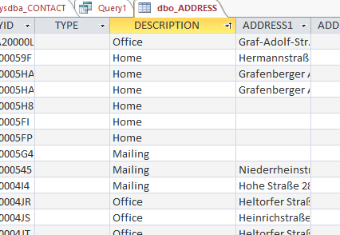

1. This is how the both tables are related:

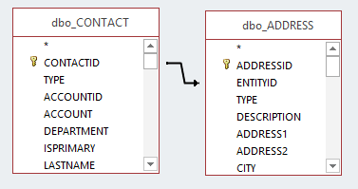

1. Here the exaple of Michael Reimann again:

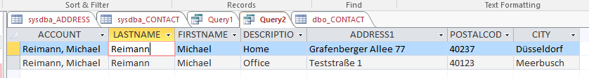

1. Test / develop database

